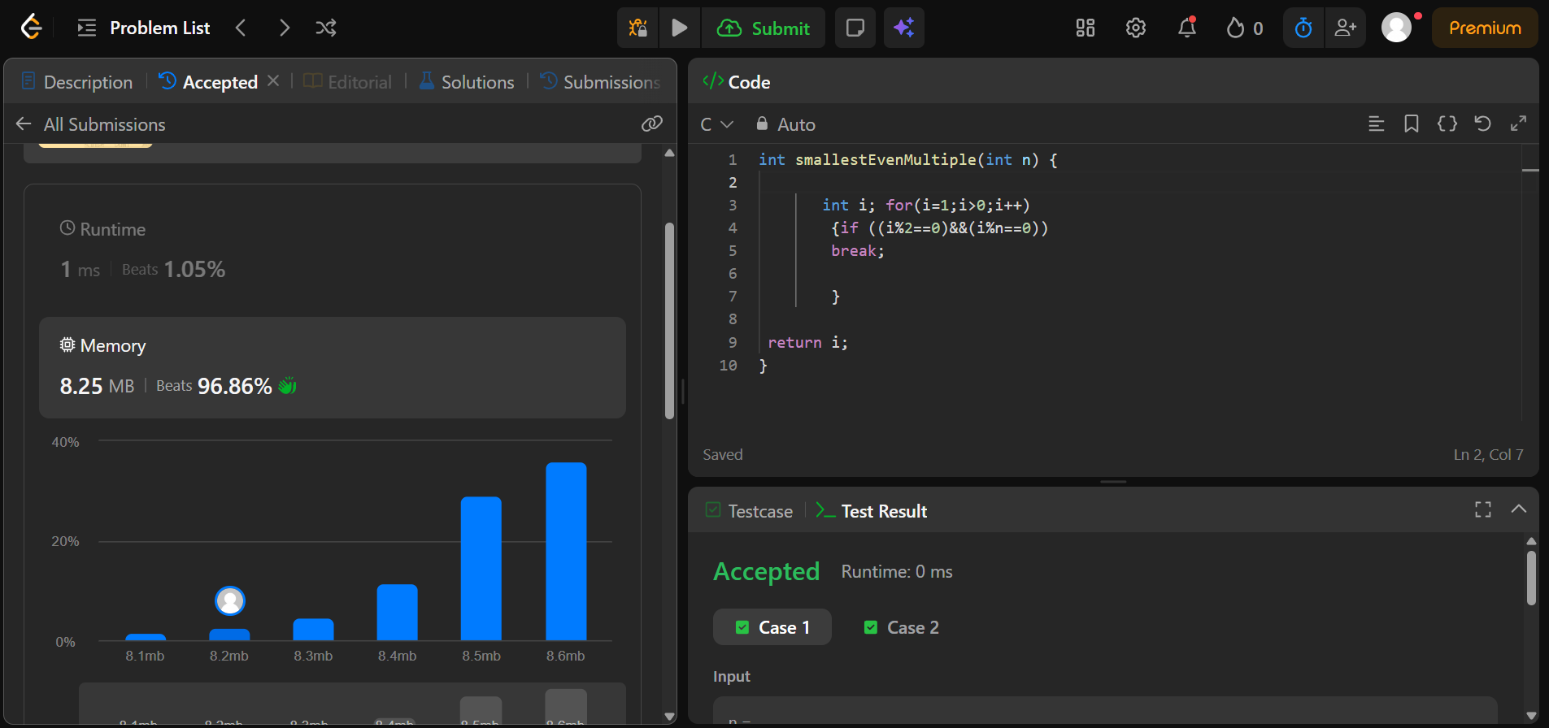
https://leetcode.com/problems/smallest-even-multiple/

int smallestEvenMultiple(int n) {

int i; for(i=1;i>0;i++)
{if ((i%2==0)&&(i%n==0))
break;

}

return i;
}

